Lane Cove Chiropractic October Newsletter

News Updates!
Did you know 75% of the world’s population spends hours daily hunched over their handheld devices with their heads flexed forward, they are all in constant danger and are at risk of developing Text Neck. The frequent forward flexion causes changes in the cervical spine, curve, supporting, supporting ligaments and tendons causing postural change.
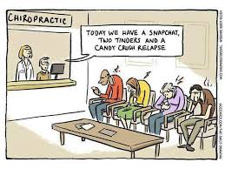
You may have noticed we have created ‘Phone Free Zones’ in our adjusting rooms. As well as adjusting you we would love to support you in changing daily habits around phone use.

Mark - Keeping you updated on the latest research
Following is a summary of 3 hot off the presses research papers – the first one is some eye-opening research on the opioid epidemic, next is information on screen time and academic performance in children and adolescents and third is on Anti-inflammatory diets.
- The 1st paper is on the association between chiropractic use and opioid use. This is an American paper, but the information is relevant for us in Australia. You may have heard that opioid drug addiction has reached epidemic proportions both in the USA and Australia. It is estimated that there are 70-80,000 deaths a year from opioid overdose in the USA and around 2000 per year in Australia and this is getting worse each year. The death from overdose has risen 38% in the last 10 years and still increasing. So public health authorities are keen to find other methods to get pain relief and minimise the use of these potentially dangerous and highly addictive drugs.
The paper published in Pain Medicine Journal on September 27th 2019 is titled- “Association Between Chiropractic Use and Opioid Receipt Among Patients with Spinal Pain. A Systematic Review and Meta-Analysis.”
The goal of the paper was to see if there is an association between chiropractic use and opioid use.
The researchers found that chiropractic users had a 64% lower odds of getting an opioid prescription than a non-chiropractic user for spinal pain (neck and lower back pain especially)
- The second paper is called –“Association Between Screen Media Use and Academic Performance Among Children and Adolescents. A Systematic Review and Meta- Analysis.” Published in JAMA Pediatrics , September 23, 2019.
The aim of this paper was to see if there was any association between screen based activities and academic performance in kids and teenagers.
And, surprise, surprise- they found that TV viewing and video game playing were inversely associated with academic performance. In other words, the more screen time the worse the academic performance. But you already knew that right? Still it’s nice to have science to back us up when we’re yelling at our kids to get off the video game and do their homework. The research also showed that TV and video games were the worst culprits.
- Is Anti-Inflammatory Diets- This paper is a bit older, but still highly relevant and is from Harvard Medical School. The paper is titled “Foods That Fight Inflammation” and was published in 2014.
Inflammation isn’t just when you get a swollen ankle from a sprain or a sore throat from a cold or flu. Inflammation is implicated in many major diseases like cancer, heart disease, diabetes, arthritis, depression and even Alzheimers Disease.
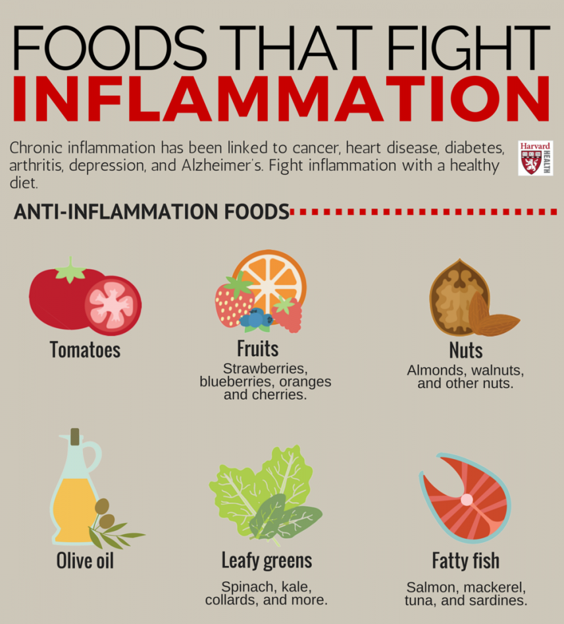
One of the lead researchers in this study Dr Frank Hu said- “Many experimental studies have shown that components of food and beverages may have anti-inflammatory effects.” One of the healthiest, natural and drug free ways you can reduce your risk of these deadly and serious diseases is to eat more of the right stuff.
The anti-inflammatory foods highlighted in the study are-
- Tomatoes
- Olive oil
- Green leafy vegetables
- Nuts- almonds and walnuts
- Fatty fish- salmon, mackerel, tuna, sardines
- Fruits – strawberries, blueberries, cherries and oranges
No surprises there, right? And just to finish off and put you off your morning tea, some of the foods which can CAUSE inflammation in your body.
Warning- this list may cause feelings of anxiety and depression-
- Refined carbohydrates- white bread, pastries
- French fries/ chips
- Sugary carbonated drinks including most sport drinks
- Margarine
Sorry to end on a downer…

What we’re up to

Julie
Julie has been busy completing an evidence-based birth course to keep her up to date with the latest research and information on pregnancy and birth to help better support the parents she cares for. It can be tricky at times navigating this area.

Very soon she will be presenting some of this material in the form of workshops for parents, pregnant families and people planning pregnancy.

Mark
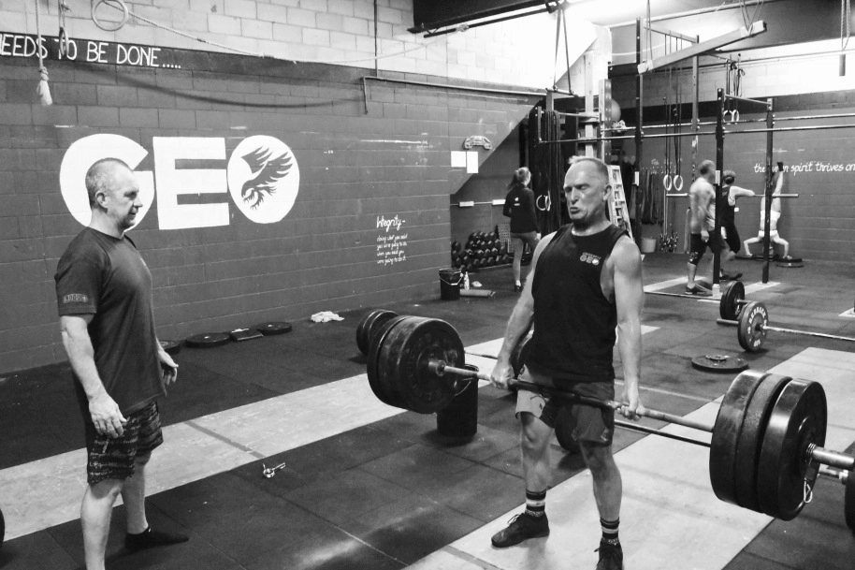
Mark is preparing for the Crossfit World Masters
Functional Fitness Championships next weekend
24th- 27th October in Queensland.
For those interested in more on this competition and
Functional Fitness generally go to
www.if3mastersworlds.com.au

Mark will be away from practice on these dates
and will be back in the practice as usual Tuesday 29th
October. Hopefully in one piece.

Julie will be covering for Mark on Thursday 24th
October.

Christina
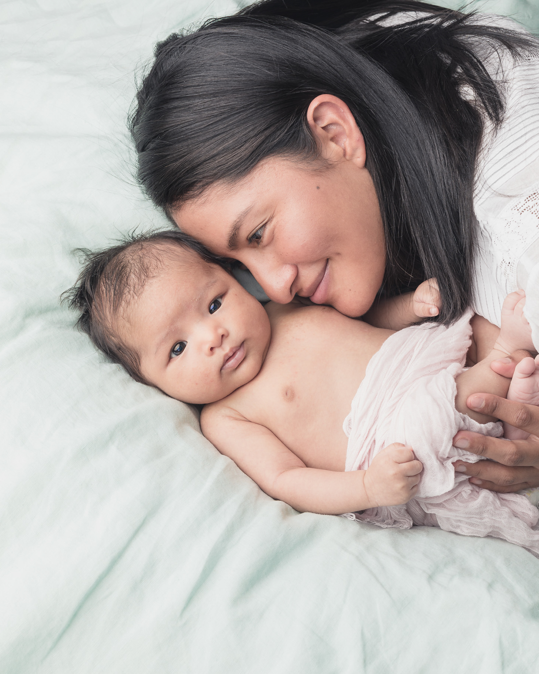
Christina and her partner Jos have been enjoying their new Bub Ariana Valentina she arrived 12 weeks ago. They are all well and loving parenting Ariana. She is a delight and visits Lane Cove Chiro regularly for her adjustments. Julie was privileged to be invited to share the birth experience with Christina and Jos. You may see Christina back in the office toward the end of this year as she covers for holidays and weddings.

Sarah (our acupuncturist and massage therapist)
Sarah has just come back from an epic holiday to the Gulf of Carpentaria she is now back to her usual hours.

Ali
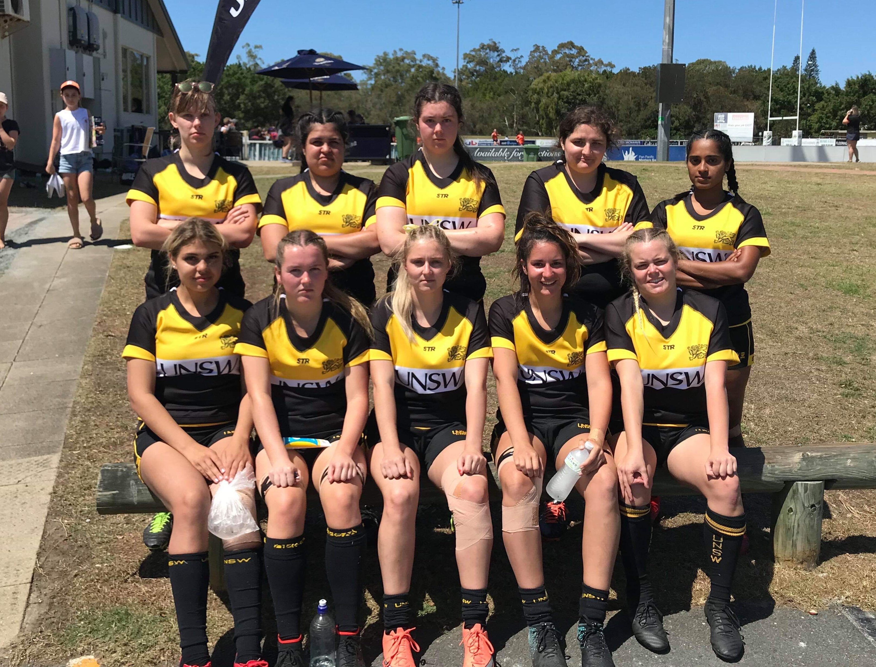
This year I’ve started playing Rugby 7’s for UNSW and recently went to the Gold Coast to compete at the University Games. I played four games a day, got absolutely smashed, potentially broke my finger and couldn’t help but laugh when a girl got yellow carded for high tackling me (just as well!).
But most importantly I am in one piece and had so much fun!

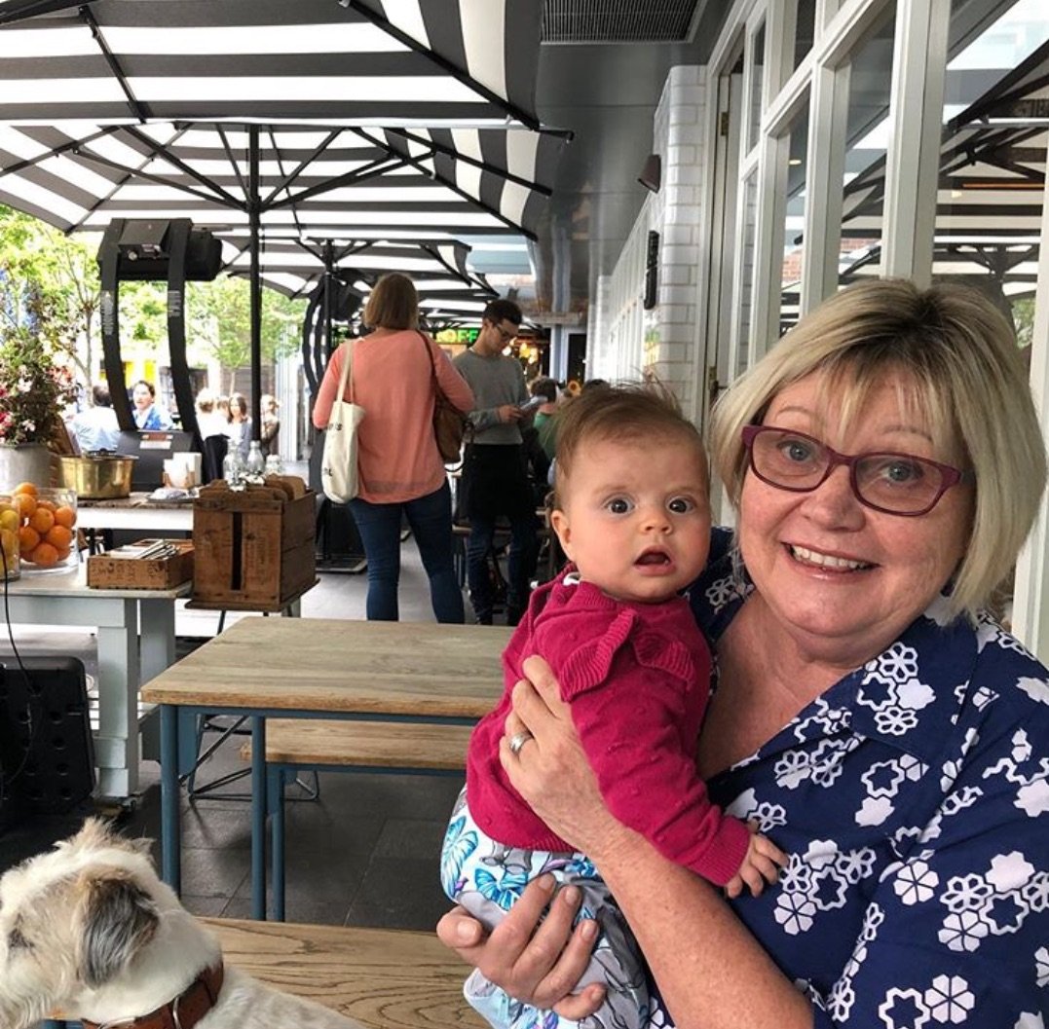
Ann

Ann is enjoying spending more time with her grandchildren. You can still see Ann in the office on Tuesday mornings except when she is off travelling the world with her husband Ian. Here she is having lunch with her gorgeous granddaughter Freja. Ann recently organized Julie and Mark to tidy up the garden you may have noticed this as you come into the office. We are excited to see the gardenias bloom with their beautiful fragrance.

Hannah

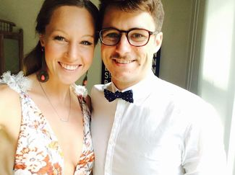
Early December I will be heading down to beautiful Berry to get married! Angus and I got engaged after 6 years together and booked our venue, photographer and all the vendors on a gamble for a date which was lots of fun and not at all stressful! We wanted to book the wedding to coincide with Fairgrounds Festival in Berry, which is an awesome family friendly music festival which we had been to previously and saw Gang of Youths, Future Island, The Shins and heaps more. The date wasn’t released until 14 months after we booked everything and with a huge relief guessed right! We have family coming from Newcastle, Orange, NSW and QLD so will be a fun weekend with lots of loved ones.

